Supplemental Information
[Journal Name]
DOI: xx/xxx

Habitat Quantity Drives Community Assembly and Feedbacks to Coral Condition in Reef Systems

Adrian C. Stier¹, Alexander Primo², Joseph S. Curtis^{1,3}, Craig W. Osenberg²
¹Department of Ecology, Evolution, and Marine Biology, and Marine Science Institute, University of California Santa Barbara, Santa Barbara, California 93106, USA; E-mail: astier@ucsb.edu , ORCID: 0000-0002-4704-4145
²Odum School of Ecology, University of Georgia, 140 E Green St, Athens, GA 30602; E-mail: osenberg@uga.edu ORCID: 0000-0003-1918-7904
³Department of Marine Science, University of Otago, PO Box 56, Dunedin, Otago, New Zealand, 9054; Email: joseph.curtis@otago.ac.nz; ORCID: 0000-0003-1567-4385

Contents:

Coral Tissue Traits
- Methods
- Literature Cited
- Figures and Tables
  - Figure S1. Physiological and growth responses of corals to treatments.
  - Table S1. Treatment effects on individual coral performance metrics.
  - Table S2. Species-level relationships between CAFI density and coral condition.
  - Table S3. Pearson correlation coefficients between species abundance and coral metrics.

Coral Tissue Traits

Methods
To assess coral tissue characteristics, we collected fragments from experimental colonies during field surveys in May 2021 and froze them at −20 °C for no more than one month. We removed tissue from each nubbin with filtered seawater and compressed air using an Iwata airbrush connected to a SCUBA tank, which generated a homogenized tissue slurry. We recorded slurry volume and, when necessary, diluted samples to a minimum of 10 mL. Before all subsampling steps, we processed the slurry with a handheld tissue homogenizer until any visible chunks were dispersed, usually ~30 seconds. We estimated fragment surface area by paraffin wax dipping, using calibration curves generated from dowels of known surface area (Veal et al. 2010).
After tissue removal, we recorded slurry volume and immediately froze samples at −20 °C for no more than one month. Upon return to UCSB, we thawed samples and re-homogenized the slurry with a handheld tissue homogenizer (~30 seconds). We then collected 1 mL aliquots for ash-free dry mass (AFDM) determination, dried aliquots at 60 °C for 24 h, weighed them, combusted them at 550 °C for 5 h, and then weighed the residual ash (Davies 1989). We stored the remaining slurry at −20 °C for subsequent protein and carbohydrate analyses. Before biochemical assays, we thawed and re-homogenized samples, then centrifuged 1 mL aliquots at 1500 × g for 4 min to remove skeletal debris and used the clarified supernatant for assays. We quantified protein using a bicinchoninic acid (BCA) assay with BSA standards (Smith et al. 1985): 25 µL of supernatant (diluted 4:1 with Milli-Q water) was incubated with 200 µL of reagent at 37 °C for 30 min, and absorbance was read at 562 nm. We measured carbohydrate content using a modified phenol–sulfuric acid method (Dubois et al. 1956): 200 µL of clarified supernatant was combined with 800 µL Milli-Q water, 25 µL phenol, and 2.5 mL sulfuric acid, incubated at 26 °C for 30 min, and absorbance was read at 485 nm.
We quantified Symbiodiniaceae densities from 10 µL subsamples taken directly from the re-vortexed homogenate. We loaded subsamples onto a hemocytometer and counted cells at 10× magnification in at least four quadrants. We added quadrants until at least 200 cells were enumerated and repeated counts until the coefficient of variation among replicate fields was <10%. If variation exceeded this threshold, we performed additional replicate counts (up to ten total). We averaged final densities across replicates and expressed them as cells per cm².

Literature Cited
Davies, P.S. (1989). Short-term growth measurements of corals using an accurate buoyant weighing technique. Mar. Biol., 101, 389–395.
Dubois, M., Gilles, K., Hamilton, J., Rebers, P. & Smith, F. (1956). Colorimetric method for determination of sugars and related substances. Anal. Chem., 28, 350–356.
Veal, C.J., Carmi, M., Fine, M. & Hoegh-Guldberg, O. (2010). Increasing the accuracy of surface area estimation using single wax dipping of coral fragments. Coral Reefs, 29, 893–897.

Supporting Figures and Tables

Figure S1. Physiological and growth responses of corals to treatments differing in the number of colonies per reef (1, 3, or 6). Each panel shows the distribution of a performance metric in each treatment: protein, carbohydrate, and tissue biomass (ash-free dry weight, AFDW; all normalized to surface area), zooxanthellae cell density, and growth. Violin plots depict the full distribution of data, with embedded boxplots showing the interquartile range, whiskers showing 1.5 x the interquartile range, and horizontal line giving the median, and points representing individual colonies. Colors correspond to treatment levels (orange = 1 colony, blue = 3 colonies, green = 6 colonies).
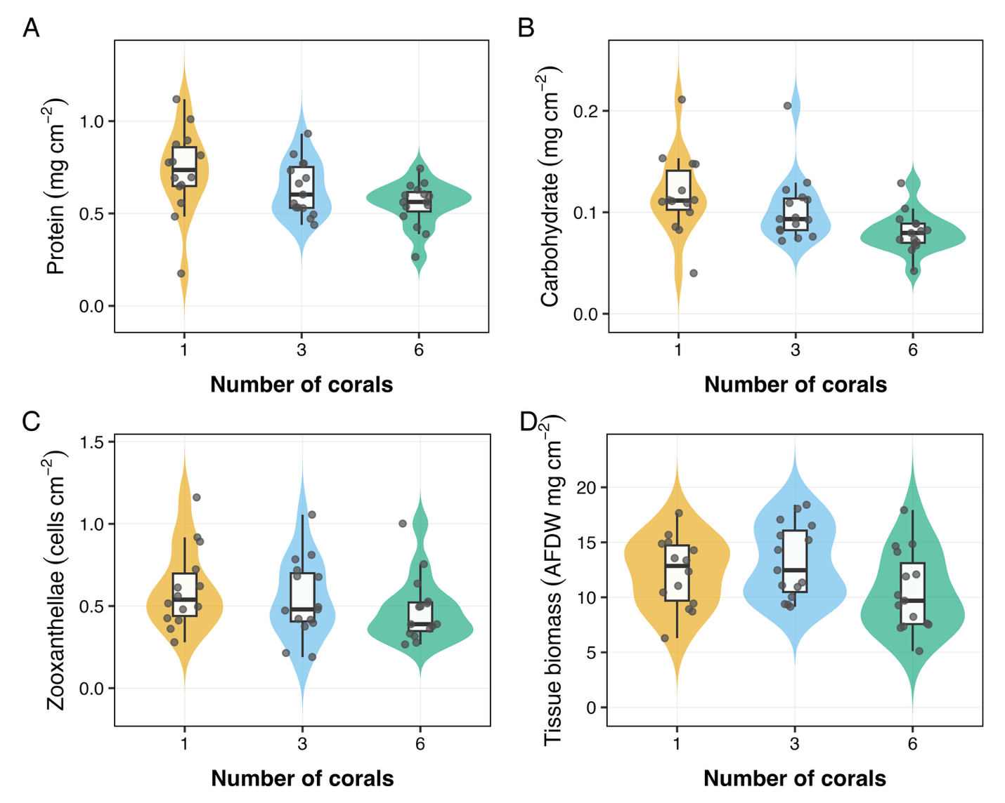

Table S1. ANOVA table evaluating treatment effects on individual coral performance metrics from univariate linear mixed-effects models, with reef included as a random intercept. The columns report the denominator degrees of freedom (df), the F-statistic from Type III ANOVA, and the resulting p-value. Models tested the effect of treatment (1, 3, or 6 corals) on individual coral physiological metrics and growth.

Response Variable | df | F | p
Carbohydrate (mg cm⁻²) | 2 | 10.047 | 0.007
Tissue biomass (AFDW mg cm⁻²) | 2 | 4.396 | 0.111
Protein (mg cm⁻²) | 2 | 3.037 | 0.219
Growth | 2 | 2.612 | 0.271
Zooxanthellae (cells cm⁻²) | 2 | 1.697 | 0.428

Table S2. Species-level relationships between CAFI density (number per coral) and coral condition (PC_{1coral}) for the top 20 CAFI taxa, with reef as a random intercept. Species are sorted by their loading on PC_{1CAFI} within each category. SE = standard error; df = degrees of freedom; t = t-statistic; p = uncorrected p-value; p (adj) = Hochberg-adjusted p-value.

Positive relationships (higher CAFI → better coral condition)
Species | β | SE | df | t | p | p (adj)
Harpiliopsis spinigera | 0.456 | 0.308 | 39.8 | 1.484 | 0.146 | 0.963
Caracanthus maculatus | 1.424 | 0.394 | 40.1 | 3.613 | 0.001 | 0.017
Periclimenes watamuae | 0.213 | 0.129 | 41.9 | 1.644 | 0.108 | 0.963
Dascyllus flavicaudus | 0.321 | 0.204 | 31.0 | 1.578 | 0.125 | 0.963
Halichoeres trimaculatus | 0.633 | 0.532 | 40.1 | 1.190 | 0.241 | 0.963
Calcinus latens | 0.454 | 0.251 | 41.8 | 1.806 | 0.078 | 0.963

Negative relationships (higher CAFI → poorer coral condition)
Species | β | SE | df | t | p | p (adj)
Alpheus lottini | -0.278 | 0.303 | 38.2 | -0.918 | 0.364 | 0.963
Paragobiodon modestus | -0.194 | 0.266 | 42.0 | -0.727 | 0.471 | 0.963
Cerithium zebrum | -0.119 | 0.287 | 42.0 | -0.416 | 0.679 | 0.963
Zafra hahajimana | 0.559 | 0.453 | 37.1 | 1.234 | 0.225 | 0.963
Apataxia cerithiiformis | -0.294 | 0.207 | 38.1 | -1.420 | 0.164 | 0.963
Diala albugo | -0.099 | 0.266 | 38.8 | -0.372 | 0.712 | 0.963
Luniella pugil | -0.917 | 0.354 | 38.5 | -2.589 | 0.014 | 0.257
Alpheus diadema | -0.995 | 0.474 | 39.1 | -2.101 | 0.042 | 0.759
Diala semistriata | -0.070 | 0.297 | 40.4 | -0.237 | 0.814 | 0.963
Mitrella moleculina | -0.342 | 0.427 | 38.0 | -0.800 | 0.428 | 0.963
Strigatella assimilis | 0.264 | 0.435 | 41.0 | 0.606 | 0.548 | 0.963
Trapezia serenei | -0.022 | 0.486 | 42.0 | -0.046 | 0.963 | 0.963
Stomatolina rubra | -0.146 | 0.472 | 40.9 | -0.309 | 0.759 | 0.963
Galathea mauritiana | -0.343 | 0.299 | 41.1 | -1.147 | 0.258 | 0.963
P-values were adjusted for multiple comparisons using the Hochberg procedure, which controls the family-wise error rate (FWER). Many adjusted p-values equal 0.963 due to the monotonicity constraint inherent to Hochberg correction: when the largest raw p-value is high (here, 0.962 for Trapezia serenei), it creates a ceiling that caps other adjusted values. This is expected behavior when testing multiple hypotheses (n=20). The alternative Benjamini-Hochberg procedure controlling false discovery rate (FDR) yields identical significant species (i.e., Caracanthus maculatus, p_FDR < 0.05).

Table S3. Pearson correlation coefficients (r) between the abundance of each coral-associated species (rows) and five coral performance metrics (columns: carbohydrate, growth, protein, tissue biomass, and zooxanthellae density). Colors indicate the direction and magnitude of the correlations: direction (color: blue = positive, red = negative) and magnitude (from white to dark). Rows are sorted by taxonomic grouping and then ordered by correlation with PC1_{coral}.
